Input JSON-

{"orderNumber":"18182589S","versionNumber":2,"orderStatus":"PAYMENT_REQUESTED","orderStatusReasonCode":"CUS_RESCEDULE_CANCEL","messageAction":"UPDATE","messageActionReason":"","companyId":"1","banner":"JewelOsco","isActive":true,"storeNumber":"0607","orderCreatedDate":"2020-09-22T07:51:11.179Z","fulfillmentSystem":"MANHATTAN","sourceInfo":{"source":"ECOMMERCE","enteredBy":"CUSTOMER","deviceType":"MOBILE","affiliate":{"affiliateName":"IBOTTA","affiliateOrderRef":"A123544334-123"}},"orderTotal":{"amount":"263.56","currency":"USD","totalCardSavings":15.51,"cardSavings":[{"savingsCategoryId":123,"savingsCategoryName":"String","savingsAmount":12.23}]},"customer":{"customerId":"556-020-1586122641346","clubCardNumber":"49130429968","isSubscription":false,"memberId":"1231321323","name":{"firstName":"JASON","lastName":"GRESS"},"address":[{"addressType":"SHIPTO","addressLine1":"14448 Donna Ln","addressLine2":" ","city":"Saratoga","state":"CA","zipCode":"95070","country":"USA"}],"contact":[{"number":"4088577000","type":"MOBILE"}],"email":[{"id":"gressholdings@gmail.com","type":"PERSONAL"}],"preference":{"termsCheckedVersionId":"0","optIn":[{"id":"4088577000","type":"TEXT","isOptin":true}]}},"paymentDetails":[{"paymentType":"CREDITCARD","paymentSubType":"AMEX","tokenNumber":"846787175413009","cardExpiryMonth":"10","cardExpiryYear":"24","zipcode":"95070","reqAuthorizationAmount":"263.56","cardHolderName":"Jason Gress","address":{"zipCode":"95070"},"paymentStatus":{"status":"NOTAUTHORIZED","authorizationCode":"201946","authorizationDate":"2020-08-13T07:51:11.233Z"}}],"subOrders":[{"subOrderNumber":1,"subOrderStatusReasonCode":"RESCHEDULE_SLOT","messageAction":"UPDATE","messageActionReason":"RESCHEDULE_SLOT","fulfillmentType":"DELIVERY","customerService":{"contact":[{"number":"8775054040","type":"PHONE","subType":"CUST_SERV_PHONE"}]},"deliveryInfo":{"deliverySubType":"RESIDENTIAL","slotInfo":{"slotPlan":"STANDARD","slotType":"FOURHR","slotId":"95e9bd9c-bedd-41ac-b0ad-04bebd4d7eb9","timeZone":"America/Los_Angeles","startTime":"2020-08-13T15:01:00.000Z","endTime":"2020-08-13T19:00:00.000Z","shiftNumber":"7","lastPickupTime":"2020-03-25T20:00:00.000Z","editingCutoffDate":"2020-08-13T08:00:00.000Z"},"deliveryServiceType":"ATTENDED","instructions":"","stageByDateTime":"2020-08-13T14:21:00.000Z","pickupInfo":{"locationType":"STORE","locationId":"1211","shortOrderNumber":4}},"charges":[{"id":"0000000029103","name":"BagFee","category":"ServiceFee","chargeAmount":{"amount":"0.1","currency":"USD"}},{"id":"0000000022155","name":"DeliveryFee","category":"DeliveryFee","chargeAmount":{"amount":"3.95","currency":"USD"}}],"promoCodes":[{"code":"SAVE20","description":"$20 Off Orders Over $75","pluCode":"00001234"}],"routeInfo":{"vanNumber":"DDS","stopNumber":"377"},"tote":{"toteEstimate":{"chilled":6,"frozen":2,"ambient":7},"toteDetails":[{"toteId":"","item":[]},{"toteId":"99800400215899","item":[{"itemId":"960027187","fulfilledUpc":[{"upcId":"003320009471","upcQuantity":1,"scannedUpc":"033200094715","pickedBy":"SYSTEM","pickedDate":"2020-08-13T09:38:01.782Z","pickType":"REGULAR"}]}]}],"totalPickedToteCount":4,"totalNumberOfBagsUsed":5},"orderLines":[{"itemId":"196011495","itemDescription":"San Luis Sourdough Bread Round - 24 Oz","orderedQuantity":1,"shortedQuantity":0,"fulfilledQuantity":1,"unitOfMeasure":"OZ","unitPrice":{"amount":"4.99","currency":"USD"},"substitutionCode":"2","substitutionValue":"Same Brand Diff Size","isRegulatedItem":false,"comments":"","fulfilledUpc":[{"upcId":"001853724157","entryId":100,"upcQuantity":1,"pickedBy":"SYSTEM","pickedDate":"2020-08-13T09:38:01.782Z","pickType":"REGULAR","scanPrice":2.33,"isSubstituted":false,"itemPrice":{"itemCode":"UPC","entryId":100,"department":30,"unitPrice":20.5,"extendedPrice":5.5,"quantityType":"LB","quantityValue":4.45,"discountAllowed":true,"linkPluNumber":"promo PLU","startDate":"2020-08-13T09:38:01.782Z","endDate":"2020-08-14T09:38:01.782Z","itemPluNumber":"embedded item PLU","pointsApplyItem":true,"wic":false,"substituted":false,"netPromotionAmount":205.49,"savings":[{"offerId":"463272","externalOfferId":"463274","category":1,"source":"CPE","linkpluNumber":"promo PLU","programCode":"SC","startDate":"2020-08-13T07:00:00.000+0000","endDate":"2020-08-14T07:00:00.000+0000","discountAmount":14.94,"discountType":"Free","description":"Default Description","discountMessage":"discount","discountLevel":"Item Level","promotionPrice":2.59,"netPromotionAmount":8.43,"points":[{"programName":"String","earn":1,"burn":1}]}]}},{"upcId":"001853724157","entryId":200,"upcQuantity":1,"pickedBy":"SYSTEM","pickedDate":"2020-08-13T09:38:01.782Z","pickType":"REGULAR","scanWeight":3.98,"isSubstituted":true,"itemPrice":{"itemCode":"UPC","entryId":100,"department":30,"unitPrice":20.5,"extendedPrice":5.5,"quantityType":"LB","quantityValue":4.45,"discountAllowed":true,"linkPluNumber":"promo PLU","startDate":"2020-08-13T09:38:01.782Z","endDate":"2020-08-14T09:38:01.782Z","itemPluNumber":"embedded item PLU","pointsApplyItem":true,"wic":false,"substituted":false,"netPromotionAmount":205.49,"savings":[{"offerId":"463272","externalOfferId":"463274","category":1,"source":"CPE","linkpluNumber":"promo PLU","programCode":"SC","startDate":"2020-08-13T07:00:00.000+0000","endDate":"2020-08-14T07:00:00.000+0000","discountAmount":14.94,"discountType":"Free","description":"Default Description","discountMessage":"discount","discountLevel":"Item Level","promotionPrice":2.59,"netPromotionAmount":8.43,"points":[{"programName":"String","earn":1,"burn":1}]}]}}],"itemPrice":{"itemCode":"UPC","entryId":100,"department":30,"unitPrice":20.5,"extendedPrice":5.5,"quantityType":"LB","quantityValue":4.45,"discountAllowed":true,"linkPluNumber":"promo PLU","startDate":"2020-08-13T09:38:01.782Z","endDate":"2020-08-14T09:38:01.782Z","itemPluNumber":"embedded item PLU","pointsApplyItem":true,"wic":false,"substituted":false,"netPromotionAmount":205.49,"savings":[{"offerId":"463272","externalOfferId":"463274","category":1,"source":"CPE","linkpluNumber":"promo PLU","programCode":"SC","startDate":"2020-08-13T07:00:00.000+0000","endDate":"2020-08-14T07:00:00.000+0000","discountAmount":14.94,"discountType":"Free","description":"Default Description","discountMessage":"discount","discountLevel":"Item Level","promotionPrice":2.59,"netPromotionAmount":8.43,"points":[{"programName":"String","earn":1,"burn":1}]}]}}]}],"storeInfo":[{"key":"isHybridStore","value":"true"},{"key":"isMFC","value":"false"},{"key":"isErumsEnabled","value":"true"},{"key":"isPremiumStore","value":"true"},{"key":"is3PLStore","value":"true"},{"key":"isDUGArrivalEnabled","value":"false"},{"key":"storeTimeZone","value":"PST"},{"key":"terminalNumber","value":"99"},{"key":"isWYSIWYGEnabled","value":"true"}],"orderInfo":{"stageByDateTime":"2020-08-13T14:21:00.000Z","data":[{"key":"key","value":"value"}]},"audit":{"createDate":"2020-08-13T12:27:32.039Z","modifiedDate":"2020-08-13T12:27:32.039Z","createdBy":"OSCO-SERVICES"}}

Publish on Kafka-

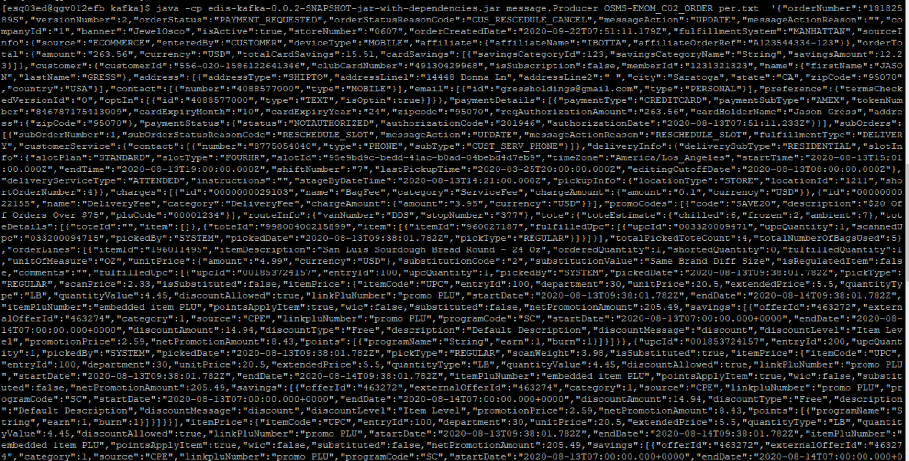

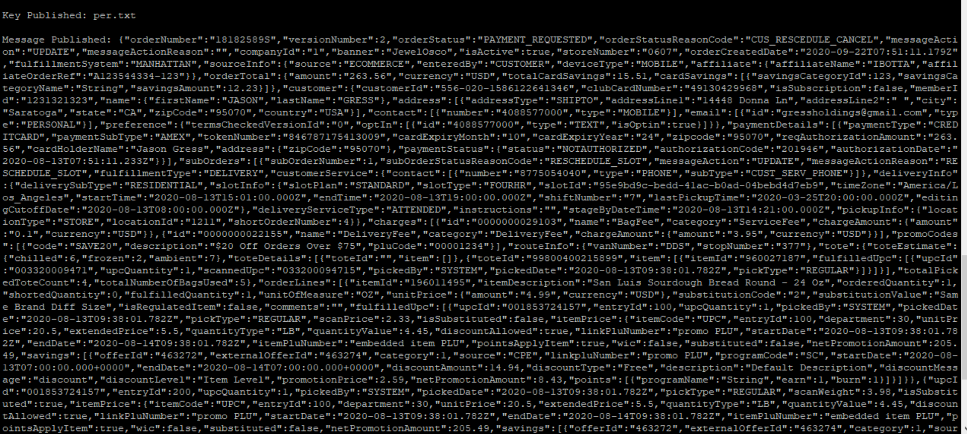

Consume on Kafka-

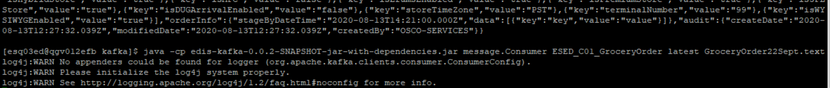

Validate in Audit table-

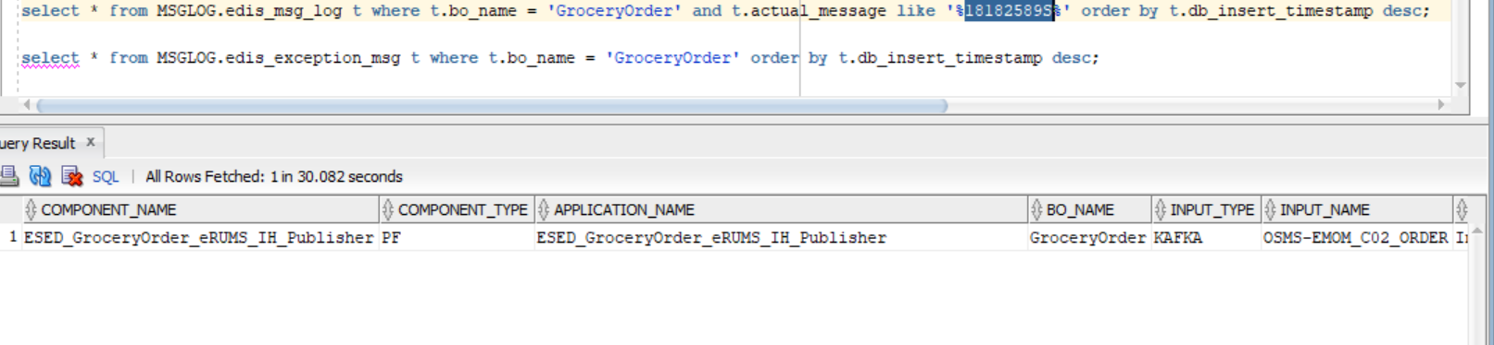

Output CMM xml-

<GetGroceryOrder xmlns:Abs="https://collab.safeway.com/it/architecture/info/default.aspx"><DocumentData><Abs:Document SystemEnvironmentCd="PROD"><Abs:DocumentID>GROCERY_ORDER</Abs:DocumentID><Abs:AlternateDocumentID>OSMS-EMOM_C02_ORDER-20200922121519370528</Abs:AlternateDocumentID><Abs:DocumentNm>GroceryOrder</Abs:DocumentNm><Abs:CreationDt>2020-09-22T12:15:19.370528</Abs:CreationDt><Abs:Description>GroceryOrderDetail</Abs:Description><Abs:SourceApplicationCd>eRUMS</Abs:SourceApplicationCd><Abs:TargetApplicationCd>EDIS</Abs:TargetApplicationCd><Abs:InternalFileTransferInd>Y</Abs:InternalFileTransferInd><Abs:DataClassification><Abs:DataClassificationLevel><Abs:Code>Internal</Abs:Code></Abs:DataClassificationLevel><Abs:BusinessSensitivityLevel><Abs:Code>Low</Abs:Code></Abs:BusinessSensitivityLevel><Abs:PHIdataInd>N</Abs:PHIdataInd><Abs:PCIdataInd>Y</Abs:PCIdataInd><Abs:PIIdataInd>Y</Abs:PIIdataInd></Abs:DataClassification></Abs:Document><Abs:DocumentAction><Abs:ActionTypeCd>UPDATE</Abs:ActionTypeCd><Abs:RecordTypeCd>CHANGE</Abs:RecordTypeCd></Abs:DocumentAction></DocumentData><GroceryOrderData><Abs:GroceryOrderHeader><Abs:OrderId>18182589S</Abs:OrderId><Abs:OrderCreateTS>2020-09-22T07:51:11.179Z</Abs:OrderCreateTS><Abs:CompanyId>1</Abs:CompanyId><Abs:VersionNbr>2</Abs:VersionNbr><Abs:OrderStatus><Abs:StatusTypeCd>PAYMENT_REQUESTED</Abs:StatusTypeCd></Abs:OrderStatus><Abs:OrderActionStatus><Abs:StatusTypeCd>UPDATE</Abs:StatusTypeCd><Abs:Description></Abs:Description></Abs:OrderActionStatus><Abs:FulfillingFacility><Abs:RetailStoreId>0607</Abs:RetailStoreId><Abs:BannerCd>JewelOsco</Abs:BannerCd><Abs:HybridStoreInd>Y</Abs:HybridStoreInd><Abs:MFCInd>N</Abs:MFCInd><Abs:ERUMSEnabledInd>Y</Abs:ERUMSEnabledInd><Abs:PremiumStoreInd>Y</Abs:PremiumStoreInd><Abs:ThirdPartyDeliveryOnlyInd>Y</Abs:ThirdPartyDeliveryOnlyInd></Abs:FulfillingFacility><Abs:GroceryOrderProfileType><Abs:ProfileType><Abs:Code>WYSIWYG</Abs:Code></Abs:ProfileType><Abs:ProfileValueInd>true</Abs:ProfileValueInd></Abs:GroceryOrderProfileType><Abs:RetailCustomer><Abs:CustomerId>556-020-1586122641346</Abs:CustomerId><Abs:CustomerNm><Abs:GivenNm>Q8xxD</Abs:GivenNm><Abs:FamilyNm>BDHT5</Abs:FamilyNm></Abs:CustomerNm><Abs:Contact><Abs:PhoneFaxContact TypeCode="MOBILE"><Abs:PhoneNbr>4D4zGn6g9l</Abs:PhoneNbr></Abs:PhoneFaxContact></Abs:Contact><Abs:Contact><Abs:DigitalContact><Abs:DigitalAddress>pJDqsSHBOyNqW@Vydgj.8qp</Abs:DigitalAddress><Abs:EmailStatuses Abs:typeCode="PERSONAL"/></Abs:DigitalContact></Abs:Contact><Abs:Contact><Abs:Address><Abs:AddressUsageTypeCd>epgjqg</Abs:AddressUsageTypeCd><Abs:AddressLine1txt>lgG9T iBOZy P6</Abs:AddressLine1txt><Abs:AddressLine2txt> </Abs:AddressLine2txt><Abs:CityNm>eNozeohY</Abs:CityNm><Abs:StateCd>Hpz</Abs:StateCd><Abs:CountryCd>USA</Abs:CountryCd></Abs:Address></Abs:Contact><Abs:ClubCardNbr>9LPMIqnFAJN</Abs:ClubCardNbr><Abs:CustomerPreference><Abs:PreferenceType><Abs:Code>TEXT</Abs:Code></Abs:PreferenceType><Abs:OptInContactNbr>4088577000</Abs:OptInContactNbr><Abs:OptInInd>true</Abs:OptInInd></Abs:CustomerPreference><Abs:CustomerSubscription><Abs:OptInInd>false</Abs:OptInInd></Abs:CustomerSubscription></Abs:RetailCustomer><Abs:CurrencyCd>USD</Abs:CurrencyCd><Abs:TotalAmt>263.56</Abs:TotalAmt><Abs:CustomerPayment><Abs:Tender><Abs:TenderId>YjQXWIpp4Uc9XX4</Abs:TenderId><Abs:TenderTypeCd>CREDITCARD</Abs:TenderTypeCd><Abs:TenderSubTypeCd>AMEX</Abs:TenderSubTypeCd><Abs:HolderNm>C9loT cjVtc</Abs:HolderNm><Abs:ExpireMonthYearTxt>xkdx</Abs:ExpireMonthYearTxt><Abs:BillingAddress><Abs:PostalZoneCd>t61WJ</Abs:PostalZoneCd></Abs:BillingAddress><Abs:PostalCd>sBhJC</Abs:PostalCd><Abs:Token><Abs:TokenId>YjQXWIpp4Uc9XX4</Abs:TokenId><Abs:TokenTypeCd>CREDITCARD</Abs:TokenTypeCd></Abs:Token><Abs:Status><Abs:StatusCd>NOTAUTHORIZED</Abs:StatusCd></Abs:Status><Abs:RequiredAuthAmt>263.56</Abs:RequiredAuthAmt><Abs:AuthCd>RzmCI2</Abs:AuthCd><Abs:AuthDt>2020-08-13T07:51:11.233Z</Abs:AuthDt></Abs:Tender></Abs:CustomerPayment><Abs:CustomerSavings><Abs:SavingsCategoryType><Abs:SavingsCategoryId>123</Abs:SavingsCategoryId><Abs:SavingsCategoryNm>String</Abs:SavingsCategoryNm><Abs:SavingsAmt>12.23</Abs:SavingsAmt></Abs:SavingsCategoryType></Abs:CustomerSavings><Abs:OrderRecordDateInfo><Abs:CreateUserId>CUSTOMER</Abs:CreateUserId></Abs:OrderRecordDateInfo><Abs:OrderCreatedDeviceType><Abs:Code>MOBILE</Abs:Code></Abs:OrderCreatedDeviceType><Abs:AffiliatePartnerType><Abs:AffiliatePartnerNm>IBOTTA</Abs:AffiliatePartnerNm><Abs:OrderReferenceTxt>A123544334-123</Abs:OrderReferenceTxt></Abs:AffiliatePartnerType><Abs:OrderSourceSystemType><Abs:Code>ECOMMERCE</Abs:Code></Abs:OrderSourceSystemType></Abs:GroceryOrderHeader><Abs:GrocerySubOrder><Abs:SubOrderNbr>1</Abs:SubOrderNbr><Abs:SubOrderStatus/><Abs:SubOrderActionStatus><Abs:StatusTypeCd>UPDATE</Abs:StatusTypeCd><Abs:Description>RESCHEDULE_SLOT</Abs:Description></Abs:SubOrderActionStatus><Abs:GroceryOrderDetail><Abs:CartLineNbr>100</Abs:CartLineNbr><Abs:ItemId><Abs:SystemSpecificItemId>196011495</Abs:SystemSpecificItemId><Abs:InternalItemId>UPC</Abs:InternalItemId><Abs:BaseProductNbr>196011495</Abs:BaseProductNbr><Abs:ItemDescription>San Luis Sourdough Bread Round - 24 Oz</Abs:ItemDescription></Abs:ItemId><Abs:UnitPriceAmt>4.9900</Abs:UnitPriceAmt><Abs:ExtendedUnitPriceAmt>5.5000</Abs:ExtendedUnitPriceAmt><Abs:Quantity>1.0000</Abs:Quantity><Abs:UOM><Abs:UOMCd>OZ</Abs:UOMCd></Abs:UOM><Abs:DiscountAllowedInd>true</Abs:DiscountAllowedInd><Abs:RewardAllowedInd>true</Abs:RewardAllowedInd><Abs:SubstitutionType><Abs:Code>2</Abs:Code><Abs:Description>Same Brand Diff Size</Abs:Description></Abs:SubstitutionType><Abs:CurrencyCd>USD</Abs:CurrencyCd><Abs:RegulatedItemInd>false</Abs:RegulatedItemInd><Abs:LinkPLUNbr>promo PLU</Abs:LinkPLUNbr><Abs:CouponPLUNbr>embedded item PLU</Abs:CouponPLUNbr><Abs:CustomerOffers><Abs:OfferId>463272</Abs:OfferId><Abs:OfferSourceType><Abs:Code>CPE</Abs:Code></Abs:OfferSourceType><Abs:CustomerRewards><Abs:RewardsProgramNm>String</Abs:RewardsProgramNm><Abs:EarnedQty>1</Abs:EarnedQty><Abs:UsedQty>1</Abs:UsedQty></Abs:CustomerRewards></Abs:CustomerOffers><Abs:Department><Abs:Code>30</Abs:Code></Abs:Department><Abs:WICItemInd>false</Abs:WICItemInd><Abs:DeliveredItem><Abs:Item><Abs:UPC><Abs:UPCTxt>001853724157</Abs:UPCTxt></Abs:UPC></Abs:Item><Abs:Item><Abs:UPC><Abs:UPCTxt>001853724157</Abs:UPCTxt></Abs:UPC></Abs:Item><Abs:UOM/></Abs:DeliveredItem></Abs:GroceryOrderDetail><Abs:GroceryOrderDetail><Abs:PromotionType><Abs:Code>SAVE20</Abs:Code><Abs:Description>$20 Off Orders Over $75</Abs:Description></Abs:PromotionType><Abs:PromotionTriggerCd>00001234</Abs:PromotionTriggerCd></Abs:GroceryOrderDetail><Abs:FullFillmentType><Abs:Code>DELIVERY</Abs:Code></Abs:FullFillmentType><Abs:PickupInfo><Abs:PickupSlot><Abs:Code>1211</Abs:Code></Abs:PickupSlot><Abs:PickupSlotType><Abs:Code>STORE</Abs:Code></Abs:PickupSlotType><Abs:DisplayEndDttm>2020-03-25T20:00:00.000Z</Abs:DisplayEndDttm></Abs:PickupInfo><Abs:DeliveryInfo><Abs:CustomerType><Abs:Code>RESIDENTIAL</Abs:Code></Abs:CustomerType><Abs:DeliverySlotId>95e9bd9c-bedd-41ac-b0ad-04bebd4d7eb9</Abs:DeliverySlotId><Abs:DeliverySlotType><Abs:Code>FOURHR</Abs:Code></Abs:DeliverySlotType><Abs:DeliveryServiceType><Abs:Code>ATTENDED</Abs:Code></Abs:DeliveryServiceType><Abs:SlotPlan><Abs:Code>STANDARD</Abs:Code></Abs:SlotPlan><Abs:StartDttm>2020-08-13T15:01:00.000Z</Abs:StartDttm><Abs:EndDttm>2020-08-13T19:00:00.000Z</Abs:EndDttm><Abs:SlotExpiryDttm>2020-08-13T19:00:00.000Z</Abs:SlotExpiryDttm><Abs:StageByDttm>2020-08-13T14:21:00.000Z</Abs:StageByDttm><Abs:EditCutoffDttm>2020-08-13T08:00:00.000Z</Abs:EditCutoffDttm><Abs:CustomerInstructionTxt></Abs:CustomerInstructionTxt><Abs:DeliveryTimeZoneCd>America/Los_Angeles</Abs:DeliveryTimeZoneCd></Abs:DeliveryInfo><Abs:ChargeInfo><Abs:Charge><Abs:Code>0000000029103</Abs:Code><Abs:Description>BagFee</Abs:Description></Abs:Charge><Abs:ChargeCategory><Abs:Code>ServiceFee</Abs:Code></Abs:ChargeCategory><Abs:ChargeAmt>0.10</Abs:ChargeAmt><Abs:CurrencyCd>USD</Abs:CurrencyCd></Abs:ChargeInfo><Abs:ChargeInfo><Abs:Charge><Abs:Code>0000000022155</Abs:Code><Abs:Description>DeliveryFee</Abs:Description></Abs:Charge><Abs:ChargeCategory><Abs:Code>DeliveryFee</Abs:Code></Abs:ChargeCategory><Abs:ChargeAmt>3.95</Abs:ChargeAmt><Abs:CurrencyCd>USD</Abs:CurrencyCd></Abs:ChargeInfo><Abs:CustomerService><Abs:PhoneFaxContact TypeCode="PHONE"><Abs:PhoneNbr>8775054040</Abs:PhoneNbr><Abs:PhonePurposes><Abs:PurposeDsc>CUST_SERV_PHONE</Abs:PurposeDsc></Abs:PhonePurposes></Abs:PhoneFaxContact></Abs:CustomerService></Abs:GrocerySubOrder></GroceryOrderData></GetGroceryOrder>

Reported Issue-

Qus: <Abs:Document SystemEnvironmentCd="PROD">

GetGroceryOrder/GroceryOrderData/GroceryOrderHeader/RetailCustomer/Contact/Address/PostalZoneCd not there but Source we are getting data

GetGroceryOrder/GroceryOrderData/GrocerySubOrder/GroceryOrderDetail/CustomerOffers/CustomerRewards/RewardsProgramId